**Cloud PRT**

**Objective 1:** Set up the primary version of the web application in N.Virginia. Tasks:

1. Acquire an Elastic IP (EIP).
2. Attach the EIP to an EC2 instance in N.Virginia.
3. Make sure to verify the EC2 instance in N.Virginia has a reliable public address.

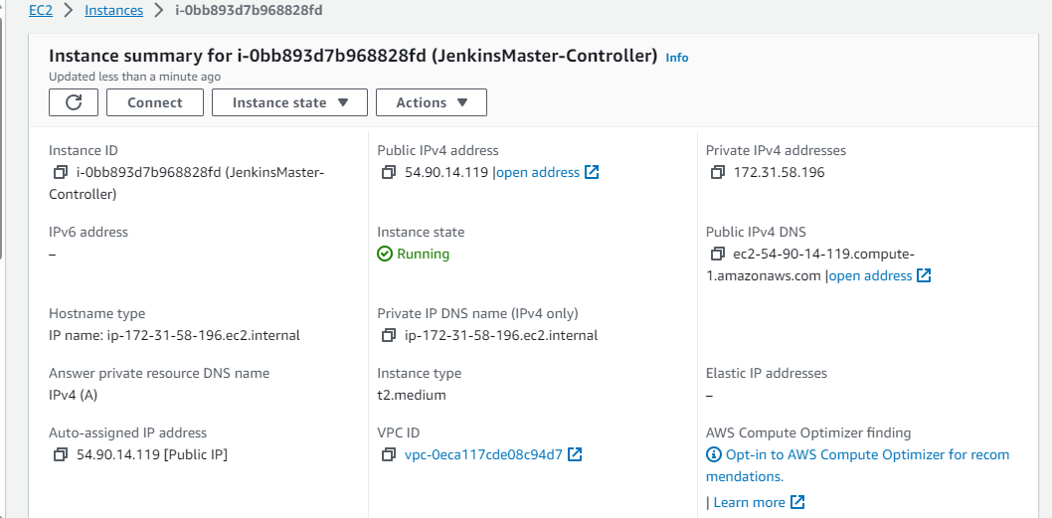

**Objective 2:** Establish a backup in Oregon to ensure high availability. - Tasks:

1. Create a backup (AMI) of this EC2 instance in a different region (Oregon).

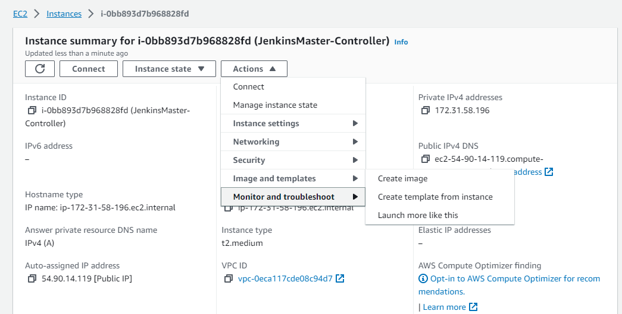

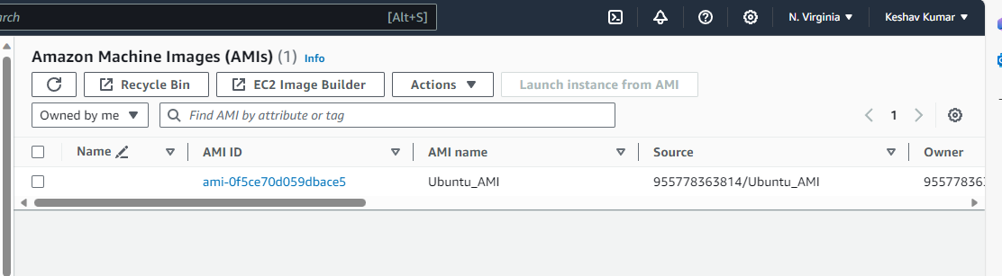

Copying AMI to Oregon

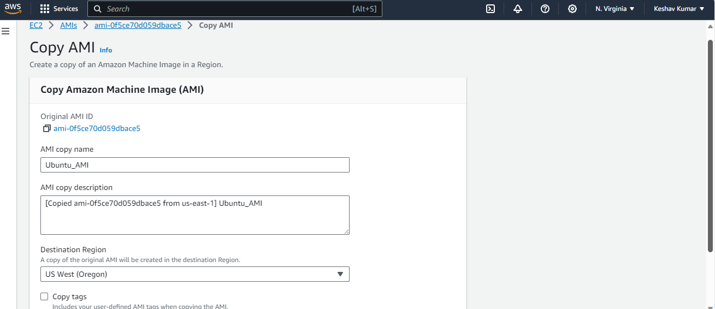

**Objective 3:** Set up an Amazon Elastic File System (EFS) for shared data storage. - Tasks:

1. Create an Amazon EFS in N. Virginia.

Ans:

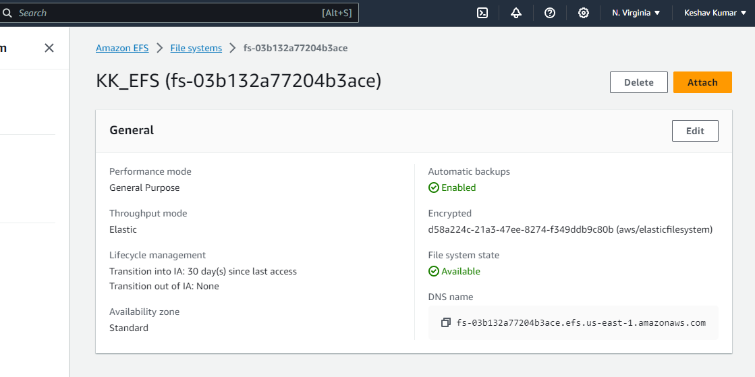

1. Create a private instance in Oregon using the above created AMI and install required dependencies to mount EFS, once dependencies are installed revoke the internet access to the instance.

Ans : 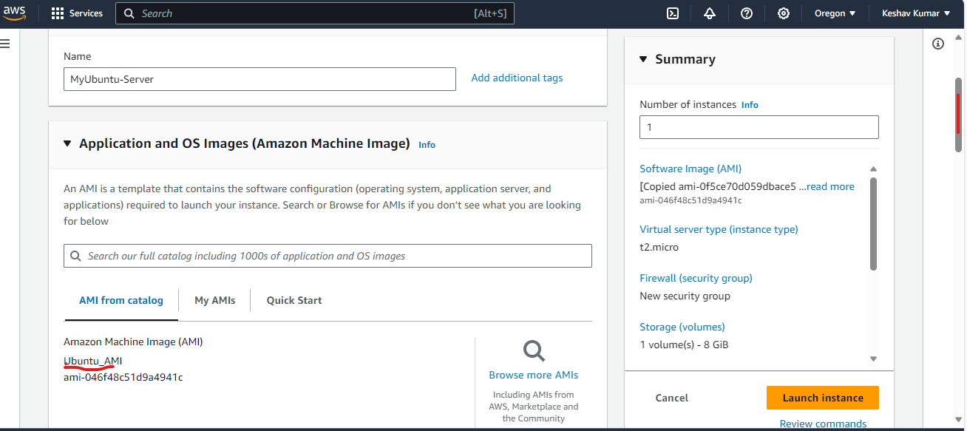

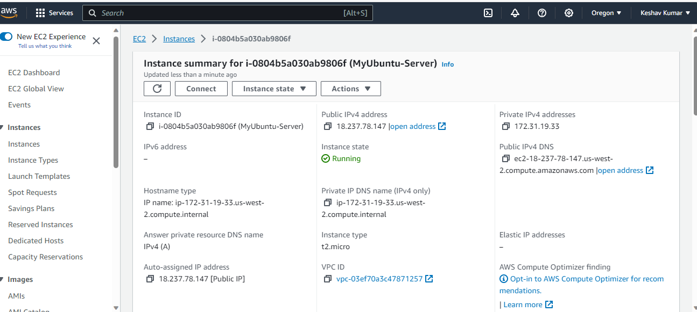

ubuntu@ip-172-31-19-33:~/efs-utils$ history

1 nano ansible_install.sh

2 ls

3 bash ansible_install.sh

4 cd /etc/

5 ls

6 cd asnsible/

7 clear

8 cd ansible

9 pwd

10 ls

11 nano hosts

12 sudo nano hosts

13 ssh ubuntu@100.25.19.144

14 ssh-keygen

15 cd

16 pwd

17 cd .ssh/

18 ls

19 cat id_rsa.pub

20 cd

21 ssh ubuntu@100.25.19.144

22 ssh ubuntu@54.165.91.61

23 clear

24 cd /etc/ansible

25 history

26 clear

27 sudo nano jenkins_install.sh

28 ls

29 sudo nano dependencies.sh

30 ls

31 sudo nano jenkins_install.sh

32 cd /etc/ansible

33 history

34 ls

35 sudo nano install.yaml

36 sudo nano jenkins_install.sh

37 sudo nano install.yaml

38 ls

39 cat hosts

40 ansible -m ping all

41 ls

42 ansible -m ping all

43 sudo nano hosts

44 ansible -m ping all

45 sudo nano hosts

46 ansible -m ping all

47 cd

48 cd .ssh

49 ls

50 cat id_rsa.pub

51 ansible -m ping all

52 ansible-playbook install.yaml

53 cd /etc/ansible

54 ansible -m ping all

55 ls

56 ansible-playbook install.yaml

57 history

58 pwd

59 java --version

60 docker --version

61 sudo service jenkins.sh status

62 /var/lib/jenkins/secrets/initialAdminPassword

63 sudo /var/lib/jenkins/secrets/initialAdminPassword

64 sudo cat /var/lib/jenkins/secrets/initialAdminPassword

65 git clone https://github.com/keshavd1/DevOpsProfessional.git

66 ls

67 cd DevOpsProfessional

68 ls

69 sudo nano dockerfile

70 ls

71 git status

72 git add dockerfile

73 git status

74 git commit -m "adding dockerfile"

75 git push origin master

76 git branch

77 ls

78 cd DevOpsProfessional/

79 git branch

80 git branch develop

81 git branch

82 git checkout develop

83 ls

84 git push oring develop

85 git push origin develop

86 exit

87 sudo apt update

88 sudo nano terraform_install.sh

89 bash terraform_install.sh

90 terraform --version

91 java -jar /usr/lib/jenkins/jenkins.war --version

92 sudo cat java -jar /usr/lib/jenkins/jenkins.war --version

93 clear

94 sudo nano main.tf

95 ls

96 terraform init

97 terraform plan

98 terrform apply

99 terraform apply

100 sudo nano main.tf

101 terraform apply

102 ls

103 sudo bash terraform_install.sh

104 ls

105 sudo nano terraform_install.sh

106 sudo nano main.tf

107 sudo bash main.tf

108 terraform apply main.tf

109 terraform init

110 terraform plan

111 terraform apply main.tf

112 terraform apply

113 sudo apt update

114 terraform init

115 terraform plan

116 terraform apply

117 ansible --version

118 cd /etc/ansible/

119 ls

120 suno nano hosts

121 sudo nano hosts

122 ansible all --list-hosts

123 sudo nano install.yaml

124 ansible -m ping all

125 sudo nano install.yaml

126 sudo apt update

127 ansible-playbook install.yaml

128 cd

129 ls

130 terraform version

131 sudo nano main.tf

132 exit

133 sudo apt update

134 ls

135 cat main.tf

136 ld

137 ls

138 sudo nano vpc.tf

139 ls

140 terraform init

141 ls

142 sudo nano main.tf

143 cat main.tf

144 sudo nano vpc.tf

145 ls

146 rm main.tf

147 ls

148 sudo rm main.tf

149 ls

150 terraform init

151 mkdir terraform-vpc

152 ls

153 cd terraform-vpc/

154 sudo nano var.tf

155 sudo nano provider.tf

156 sudo nano var.tf

157 ls

158 ls -l

159 terraform init

160 ls

161 ls -a

162 sudo nano vpc.tf

163 sudo nan0 network.tf

164 sudo nano network.tf

165 ls

166 sudo nano var.tf

167 terraform plan

168 terraform plan -out terraform.out

169 ls

170 sudo rm network.tf

171 sudo rm provider.tf

172 sudo rm vpc.tf

173 ls

174 sudo rm var.tf

175 ls

176 sudo nano main.tf

177 terraform init

178 terraform plan

179 terform apply

180 terraform apply

181 clear

182 sudo nano main.tf

183 terraform plan

184 terraform init

185 terraform plan

186 terraform apply

187 sudo nano var.tf

188 sudo nano variables.tf

189 sudo rm var.tf

190 ls

191 sudo nano main.tf

192 terraform plan

193 sudo nano main.tf

194 terraform plan

195 sudo nano main.tf

196 terraform plan

197 terrafom apply

198 terraform apply

199 sudo nano main.tf

200 terraform plan

201 terraform apply

202 sudo nano main.tf

203 terraform plan

204 terraform apply

205 sudo nano variables.tf

206 sudo nano main.tf

207 terraform plan

208 terraform apply

209 sudo nano main.tf

210 terraform plan

211 terraform apply

212 sudo nano main.tf

213 terraform plan

214 terraform apply

215 sudo apt update

216 sudo mount -t efs -o tls fs-03b132a77204b3ace:/ efs

217 sudo mount -t nfs4 -o nfsvers=4.1,rsize=1048576,wsize=1048576,hard,timeo=600,retrans=2,noresvport fs-03b132a77204b3ace.efs.us-east-1.amazonaws.com:/ efs

218 sudo mount -t nfs4 -o nfsvers=4.1,rsize=1048576,wsize=1048576,hard,timeo=600,retrans=2,noresvport 172.31.32.127:/ efs

219 sudo yum install -y amazon-efs-utils

220 sudo apt-get update git clone https://github.com/aws/efs-utils sudo apt-get -y install binutils cd efs-utils./build-deb.sh sudo apt-get -y install./build/amazon-efs-utils*deb

221 sudo apt-get update

222 sudo apt-get -y install binutils

223 cd efs-utils

224 ./build-deb.sh

225 sudo apt-get -y install ./build/amazon-efs-utils*deb

226 sudo apt-get update

227 sudo apt-get -y install ./build/amazon-efs-utils*deb

228 sudo mkdir /mnt/efs

229 sudo chmod 775 /mnt/efs

230 sudo chown -R $USER /mnt/efs

231 sudo mount -t nfs4 -o nfsvers=4.1,rsize=1048576,wsize=1048576,hard,timeo=600,retrans=2,noresvport fs-03b132a77204b3ace.efs.us-east-1.amazonaws.com:/ efs

232 sudo apt-get install -y amazon-efs-utils

233 sudo apt-get install -y amazon-efs-utils https://github.com/aws/efs-utils

234 sudo apt-get update git clone https://github.com/aws/efs-utils sudo apt-get -y install binutils cd efs-utils./build-deb.sh sudo apt-get -y install./build/amazon-efs-utils*deb

235 sudo apt -y install git binutils

236 git clone https://github.com/aws/efs-utils

237 cd efs-utils

238 ./build-deb.sh

239 sudo apt -y install ./build/amazon-efs-utils*deb

240 sudo mount -t efs -o tls fs-03b132a77204b3ace:/ efs

241 sudo mount -t nfs4 -o nfsvers=4.1,rsize=1048576,wsize=1048576,hard,timeo=600,retrans=2,noresvport fs-03b132a77204b3ace.efs.us-east-1.amazonaws.com:/ efs

242 sudo pip3 install botocore --upgrade

243 sudo apt-get -y install wget

244 sudo mount -t efs -o tls fs-03b132a77204b3ace:/ efs

245 sudo apt update

246 sudo mount -t efs -o tls fs-03b132a77204b3ace:/ efs

247 if echo $(python3 -V 2>&1) | grep -e "Python 3.6"; then sudo wget https://bootstrap.pypa.io/pip/3.6/get-pip.py -O /tmp/get-pip.py; elif echo $(python3 -V 2>&1) | grep -e "Python 3.5"; then sudo wget https://bootstrap.pypa.io/pip/3.5/get-pip.py -O /tmp/get-pip.py; elif echo $(python3 -V 2>&1) | grep -e "Python 3.4"; then sudo wget https://bootstrap.pypa.io/pip/3.4/get-pip.py -O /tmp/get-pip.py; else sudo apt-get -y install python3-distutils; sudo wget https://bootstrap.pypa.io/get-pip.py -O /tmp/get-pip.py; fi

248 sudo python3 /tmp/get-pip.py

249 sudo pip3 install botocore

250 sudo /usr/local/bin/pip3 install --target /usr/lib/python3/dist-packages botocore

251 sudo mount -t efs -o tls fs-03b132a77204b3ace:/ efs

252 sudo mount -t nfs4 -o nfsvers=4.1,rsize=1048576,wsize=1048576,hard,timeo=600,retrans=2,noresvport fs-03b132a77204b3ace.efs.us-east-1.amazonaws.com:/ efs

253 sudo pip3 install botocore --upgrade

254 sudo apt update

255 sudo mount -t efs -o tls fs-03b132a77204b3ace:/ efs

256 sudo mount -t nfs4 -o nfsvers=4.1,rsize=1048576,wsize=1048576,hard,timeo=600,retrans=2,noresvport 172.31.32.127:/ efs

257 NFS: nfs4_discover_server_trunking unhandled error -512. Exiting with error EIO

258 sudo mount -t nfs -o nfsvers=4.1,rsize=1048576,wsize=1048576,hard,timeo=600,retrans=2,noresvport mount-target-ip:/ ~/efs-mount-point

259 clear

260 sudo mount -t efs -o tls fs-03b132a77204b3ace:/ efs

261 sudo su

262 history

ubuntu@ip-172-31-19-33:~/efs-utils$